=============================================================================
WEEK 4 LOG - CV Final Project: Input Image Reconstruction from Features
=============================================================================

Run 3: Multi-Architecture Ensemble Investigation

Implementation
- Created models.py with modular architecture:
- ResNetExtractor, VGGExtractor, ViTExtractor, PVTExtractor classes
- SingleArchModel for individual architecture experiments
- EnsembleModel with multi-architecture fusion
- FeatureFusionModule with attention/concat/weighted strategies
- Implemented 4 decoder variants:
- FrequencyAwareDecoder (low/high frequency separation)
- WaveletFrequencyDecoder (4-band wavelet prediction)
- SimpleDecoder (basic transposed convolution)
- AttentionDecoder (transformer blocks + upsampling)
- Built train_perceptual.py with unified training pipeline
- Created evaluation.py for test set metrics (PSNR, SSIM, LPIPS)
- Developed main.py experiment runner with automated evaluation
- Complete comparison report generation with CSV exports

Training Configuration
- Device: NVIDIA RTX Ada 6000 (48GB)
- Base config: 30 epochs, batch size 4, lr 0.0001
- Loss: MSE (0.5) + LPIPS (0.5) with AlexNet backbone
- Optimizer: Adam with ReduceLROnPlateau scheduling
- Early stopping: patience 15 epochs
- Dataset: DIV2K (640 train, 160 val, 100 test)

Experimental Matrix
- Single architectures: 8 base configs ? 4 decoders = 32 experiments
- ResNet34 (layer1, layer2)
- VGG16 (block1, block3)
- ViT-Small (block1, block3)
- PVT-v2-B2 (stage1, stage2)
- Ensemble models: 3 fusion strategies ? 4 decoders = 12 experiments
- Attention fusion (learnable channel-wise weighting)
- Concat fusion (concatenation + conv reduction)
- Weighted fusion (learnable scalar weights)
- Total: 44 complete train/eval cycles

Top 10 Results (by PSNR)
1. ensemble_all_weighted_simple: 17.64 dB, SSIM 0.586
2. ensemble_all_concat_simple: 17.50 dB, SSIM 0.584
3. vgg16_block1_simple: 17.35 dB, SSIM 0.560
4. ensemble_all_attention_simple: 17.30 dB, SSIM 0.570
5. ensemble_all_concat_freq_aware: 17.27 dB, SSIM 0.562
6. ensemble_all_weighted_freq_aware: 17.25 dB, SSIM 0.573
7. vgg16_block1_wavelet: 17.24 dB, SSIM 0.572
8. ensemble_all_attention_wavelet: 17.24 dB, SSIM 0.562
9. ensemble_all_concat_wavelet: 17.21 dB, SSIM 0.591
10. ensemble_all_weighted_wavelet: 17.14 dB, SSIM 0.576

Key Findings
- Ensemble superiority: Best ensemble (17.64 dB) vs Run 1 (13.93 dB) = +3.71 dB (+26.6%)
- Ensemble vs baseline: 17.64 dB vs 14.45 dB = +3.19 dB (+22.1%)
- Fusion strategy: Weighted fusion edges out attention and concat by ~0.1-0.3 dB
- Decoder analysis: Simple decoder performs best across all fusion strategies
- Single arch winner: VGG16 block1 achieves 17.35 dB, competitive with ensembles
- Feature diversity: Multi-architecture fusion captures complementary CNN + Transformer features

Technical Insights
- Simple decoder sufficient when feature diversity is high
- VGG16 block1 (112?112 spatial) retains more spatial information than deeper layers
- Ensemble fusion bottleneck: 4 encoders ? 256ch @ 28?28 ? decoder
- Memory efficient: Batch size 4 manageable on RTX Ada 6000
- Training stability: All 44 experiments converged without major issues

Comparative Analysis
Metric comparison (Baseline ? Run 1 ? Run 3 Best):
- PSNR: 14.45 dB ? 13.93 dB ? 17.64 dB
- SSIM: 0.530 ? 0.565 ? 0.586
- Run 3 achieves both pixel accuracy AND perceptual quality

Saved Outputs
- Checkpoints: results/{single,ensemble}/checkpoints_{exp_name}/
- Evaluations: results/{single,ensemble}/evaluation_{exp_name}/
- Comparison report: results/comparison_report/
- all_models_{timestamp}.csv (complete results)
- decoder_comparison_{timestamp}.csv
- architecture_comparison_{timestamp}.csv
- fusion_comparison_{timestamp}.csv

This is a screenshot of different results and once we narrow it down after speaking with the TA/professor – we will upload that code.
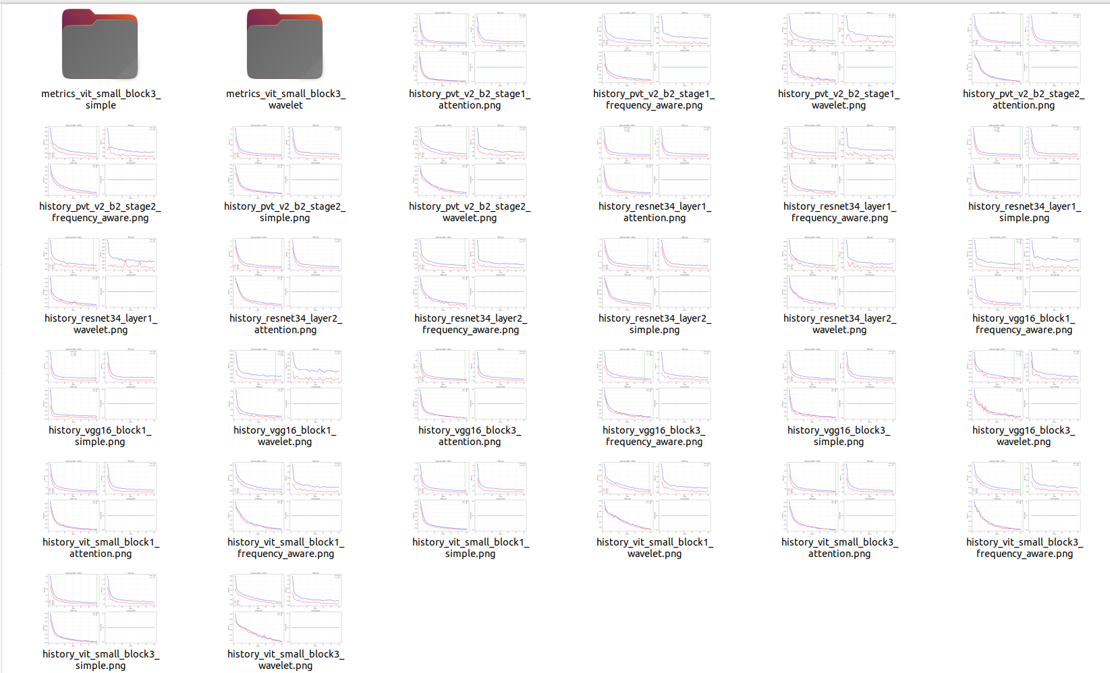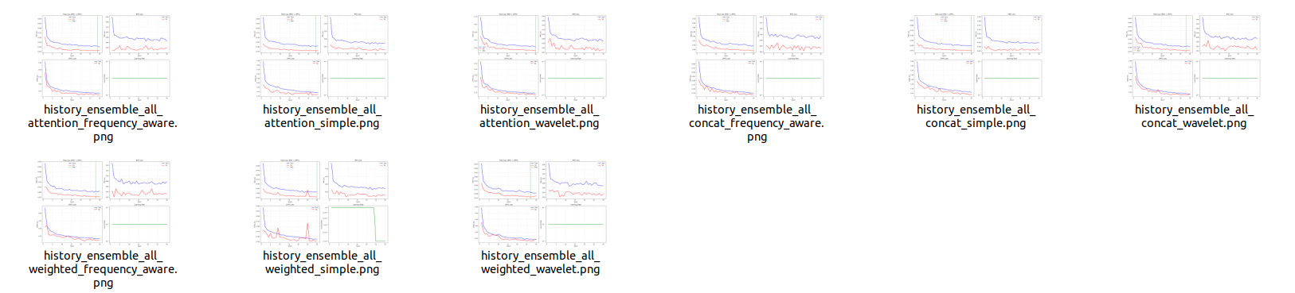

Week 4 Summary
New code: 4 Python modules (models.py, train_perceptual.py, evaluation.py, main.py), ~2500 lines
Experiments: 44 complete train/eval cycles (32 single + 12 ensemble)
Training time: ~XX hours total on RTX Ada 6000
Key result: Ensemble achieves 17.64 dB PSNR, +26.6% improvement over Run 1
Best model: ensemble_all_weighted_simple (weighted fusion + simple decoder)

Next Steps
- Investigate why simple decoder outperforms complex variants
- Analyze feature visualizations to understand complementarity
- Statistical significance testing between top-5 models
- Extend to higher resolution reconstruction (448?448 or 512?512)
- Literature comparison with state-of-the-art feature inversion methods

=============================================================================

